**REAL-TIME FACE RECOGNITION & DETECTION**

**Project Synopsis**

**Version 1.0**

Industrial Training (ECS791)

**BACHELOR OF TECHNOLOGY (CSE)**

|  |  |
| --- | --- |
| PROJECT GUIDE:  **Ms. Rohaila Naaz** | SUBMITTED BY:  **Kshma Sethi (TCA1809072)** |

October, 2021



**COLLEGE OF COMPUTING SCIENCES AND INFORMATION TECHNOLOGY**

**TEERTHANKER MAHAVEER UNIVERSITY, MORADABAD**

**Table of Contents**

1 Project Title 3

2 Domain 3

3 Problem Statement 3

4 Project Description 3

4.1 Scope of the Work 3

4.2 Project Modules 3

5 Implementation Methodology 4

6 Technologies to be used 5

6.1 Software Platform 5

6.2 Hardware Platform 5

6.3 Libraries 5

7 Advantages of this Project 5

8 Future Scope and further enhancement of the Project 5

9 Team Details 6

10 Conclusion 6

11 References 6

# Project Title

Real-time face recognition & detection.

# Domain

* Technical Domain- Machine Learning, Computer Vision
* Business Domain- Security, Social Platforms, Retail, Travelling

# Problem Statement

A face recognition system is one of the biometric information processes, its applicability is easier and working range is larger than others, i.e.; fingerprint, iris scanning, signature, etc. Face recognition is one of the important biometric methods; it deals with automatically identifying or verifying a person from a digital image or video source by comparing selected facial features. It is a form of identity access management and access control.

# Project Description

The system uses a combination of techniques in two topics; face detection and recognition. The face detection is performed on live acquired images without any application field in mind. Processes utilized in the system are white balance correction, skin like region segmentation, facial feature extraction and face image extraction on a face candidate. System is also capable of detecting and recognizing multiple faces in live acquired images.

## Scope of the Work

Facial Recognition using feature classification of a person based on only a frontal view image is something a human can easily accomplish. It can be decided by the facial features such as hair, nose, eyes, mouth and other properties with relatively high degree of accuracy. However, this will be a problem when it comes to automating the processing using a computer program. This project therefore is to solve this matter. In this project it is assumed that each image is of same size, the image quality and resolution is

assumed to be sufficient enough, the illumination is uniformed and the input images are

color images.

## Project Modules

* Data Gathering- This is the first phase of our project. We will simply create a dataset, where we will store for each id, a group of photos in gray with the portion that will be used for face detection.
* Data Training- This is the second phase of our project. We will take all user data from the dataset and the data will be fed to the OpenCV Recognizer. This is done directly by a specific OpenCV function. The result will be a .yml file.
* Data Recognizer- This is the final phase of our project. We will capture a fresh face on our camera and if this person had his face captured and trained before, our recognizer will make a “prediction” returning its id and an index. In concern to facial recognition, when the image whose face we want to detect will be fed to the system, feature matching will take place and the corresponding output will be provided.

# Implementation Methodology

The first step is face detection, the second is normalization, the third is feature extraction, and the final step is face recognition. These steps are separate components of a facial recognition system and depend on each other. It tries to find eye-analogue pixels so as to remove unwanted pixels from the image. After performing the segmentation process, it considers each eye-analogue segment as a candidate of one of the eyes. Then, a set of rule is executed to determine the potential pair of eyes. Once the eyes are selected, the algorithm calculates the face area as a rectangle. The four vertexes of the face are determined by a set of functions. Thus, the potential faces are normalized to a fixed size and orientation. Then the face regions are verified. The geometry features based methods analyze both local features and their geometric relationships. This approach is often called feature-based method. Appearance based methods represent a face in terms of several raw intensity images. An image is considered as a high-dimensional vector. Then statistical techniques are usually used to derive a feature space from the image distribution. The sample image is compared to the training set. On the other hand, the model-based approach tries to model a human face. The new sample is fitted to the model, and the parameters of the model are used to recognize the image.

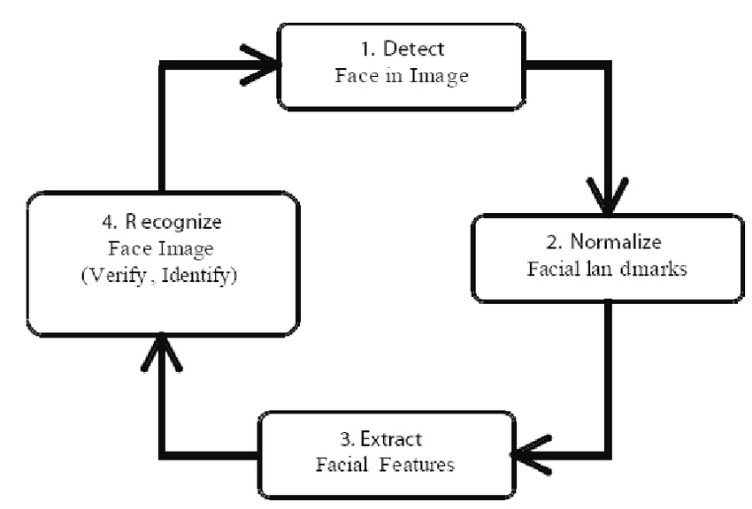

# Technologies to be used

## Software Platform

* Operating system- Windows 7 or higher versions
* Programming Language- Python 3.8 (Install Conda for python)

## Hardware Platform

RAM, Hard Disk, OS, Editor, Browser etc.

## Libraries

Numpy, OpenCV.

This project was done with “Open-Source Computer Vision Library”, the [OpenCV](https://opencv.org/). OpenCV was designed for computational efficiency and with a strong focus on real-time applications. So, it’s perfect for real-time face recognition using a camera.

# Advantages of this Project

Facial recognition has been used in several areas such as security and detection of criminals or suspects. It has been a means of authentication and access control and identity management in some private corporations. The facial recognition system is envisaged to provide suitable and reliable way for detecting the face which can be used in various sectors of importance. Face recognition is considered a passive and non-intrusive approach to verifying and identifying people.

# Future Scope and further enhancement of the Project

Today, one of the fields that uses facial recognition the most is security. Facial recognition is a very effective tool that can help law enforcers recognize criminals and software companies are leveraging the technology to help users access their technology. This technology can be further developed to be used in other avenues such as ATMs, accessing confidential files, or other sensitive materials. This can make other security measures such as passwords and keys obsolete.

* Authentication system- The face recognition system will be integrated with PC’s authentication system. If a match is found for the face image than it will log that user on. The camera will be capturing images in real-time so if a enrolled face is not detected in front of the computer, the user is logged off.

# Team Details

|  |  |  |  |  |  |
| --- | --- | --- | --- | --- | --- |
| **Group#** | **Course Name** | **Student ID** | **Student Name** | **Role** | **Signature** |
|  | Industrial Training (ECS791) | TCA1809072 | Kshma Sethi | Developer |  |

# Conclusion

The facial recognition system presented in our project which contributes a resilient face recognition model based on the mapping of behavioral characteristics with the physiological biometric characteristics. The characteristics of the human face with relevance to various features are associated with geometrical structures which restored as base matching template for the recognition system.

# References

[1] [*"How does facial recognition work?"*](https://us.norton.com/internetsecurity-iot-how-facial-recognition-software-works.html)*. us.norton.com. Retrieved 2020-02-28*

[2][*"What is Facial Recognition? - Definition from Techopedia"*](https://www.techopedia.com/definition/32071/facial-recognition)*. Techopedia.com. Retrieved 2018-08-27*

[3] R. Kimmel and G. Sapiro (30 April 2003). ["The Mathematics of Face Recognition"](https://web.archive.org/web/20070715175109/http:/www.siam.org/news/news.php?id=309). SIAM News. Archived from [the original](http://siam.org/news/news.php?id=309) on 15 July 2007. Retrieved 2003-04-30.

[4] Smith*, Kelly.*[*"Face Recognition"*](https://www.biometrics.gov/Documents/FaceRec.pdf)*(PDF). Retrieved 2008-06-04*

*[5]*  [*"Facial Recognition Market - Global Forecast to 2021"*](http://www.digitaljournal.com/pr/3187852)*. Digital Journal. Retrieved 4 January 2017*